LAB 2A: Basic Static Techniques
Course Name: Malware Analysis and Reverse Engineering (IAM302)
Student Name: Nguyễn Trần Vinh – SE160258
Instructor Name: Mai Hoàng Đỉnh
Lab Due Date: 11/1/2023

Purpose
You will practice the techniques in chapter 1.
What you need:
- A Windows computer (real or virtual) with an Internet connection
- Recommended: the textbook: "Practical Malware Analysis"

VirusTotal
- Lab01-01.dll
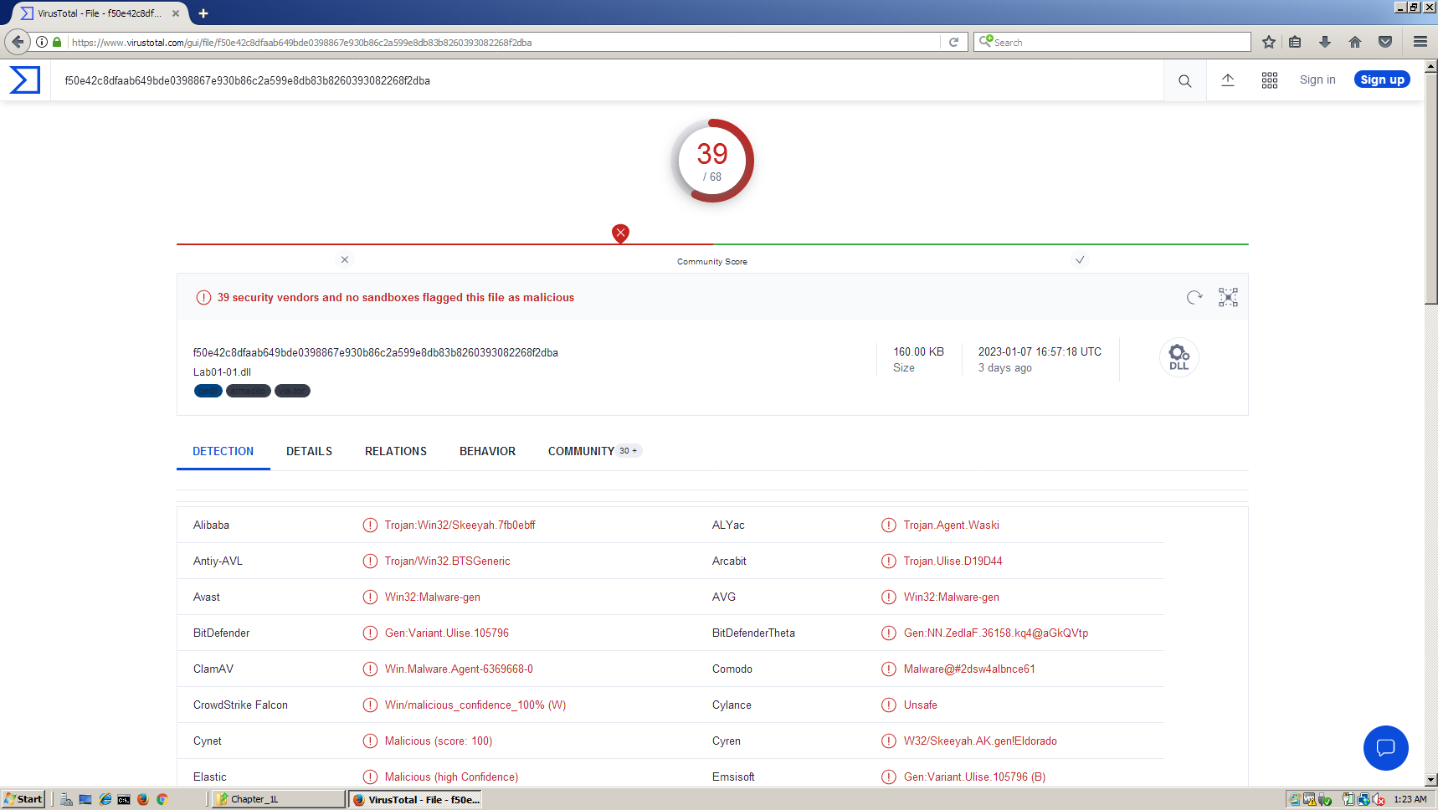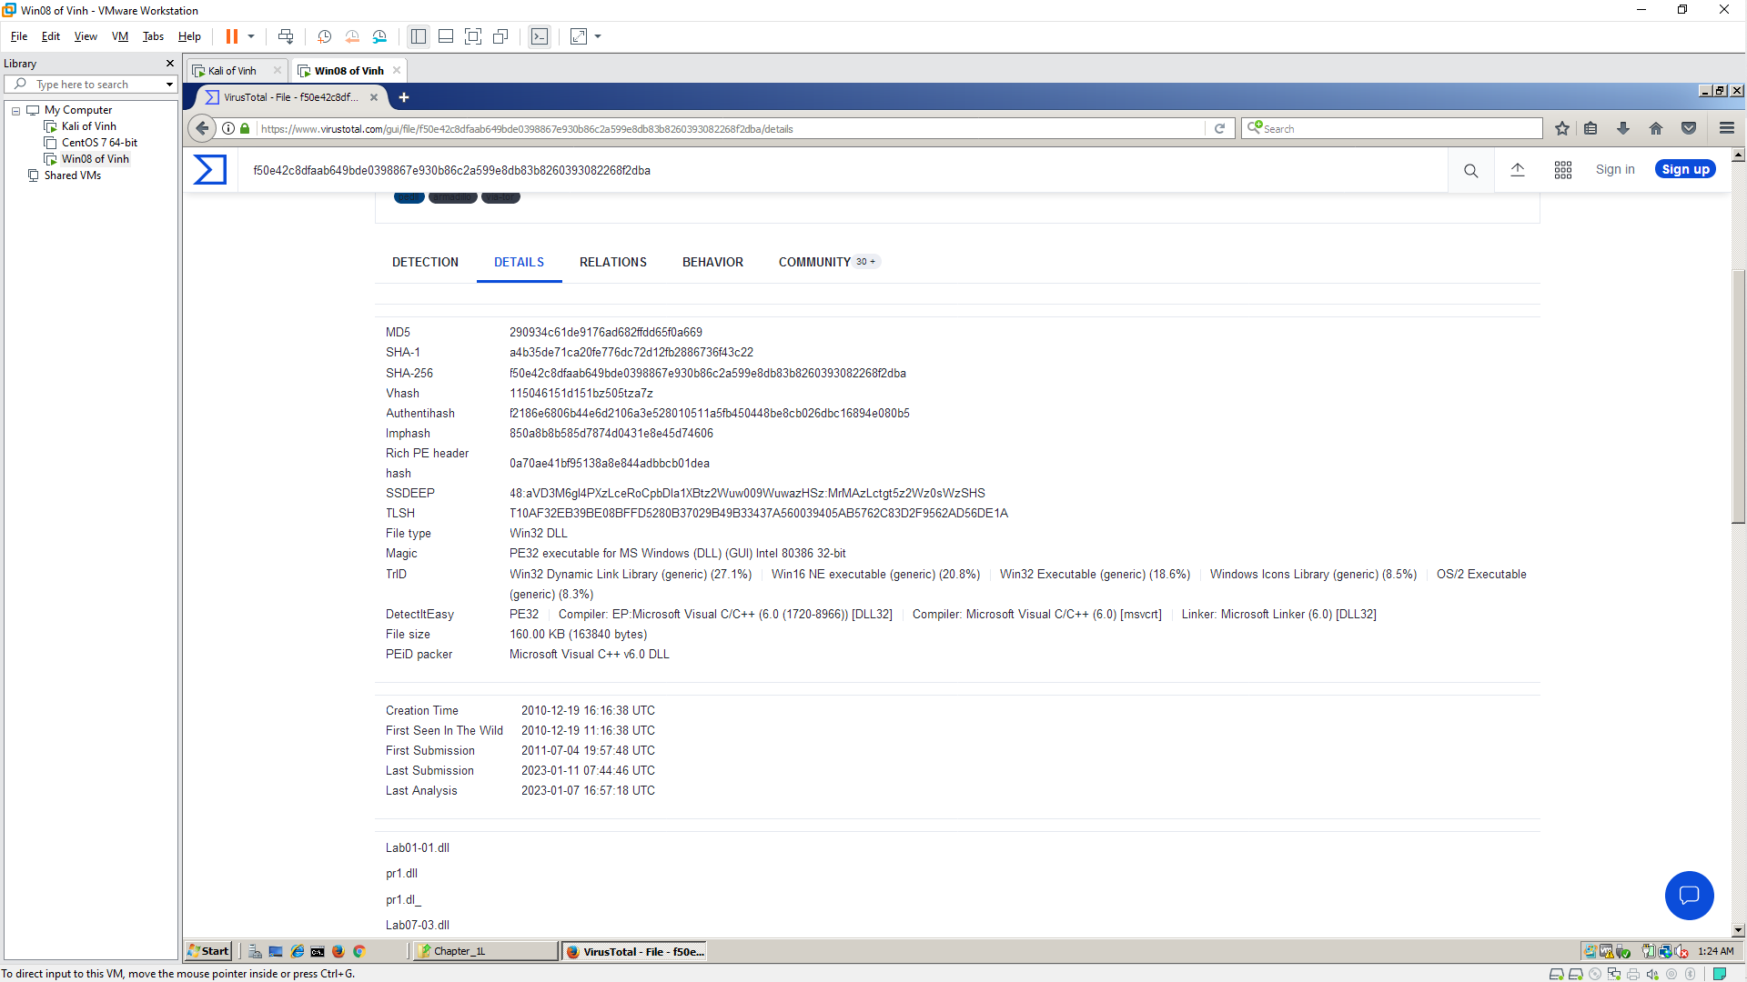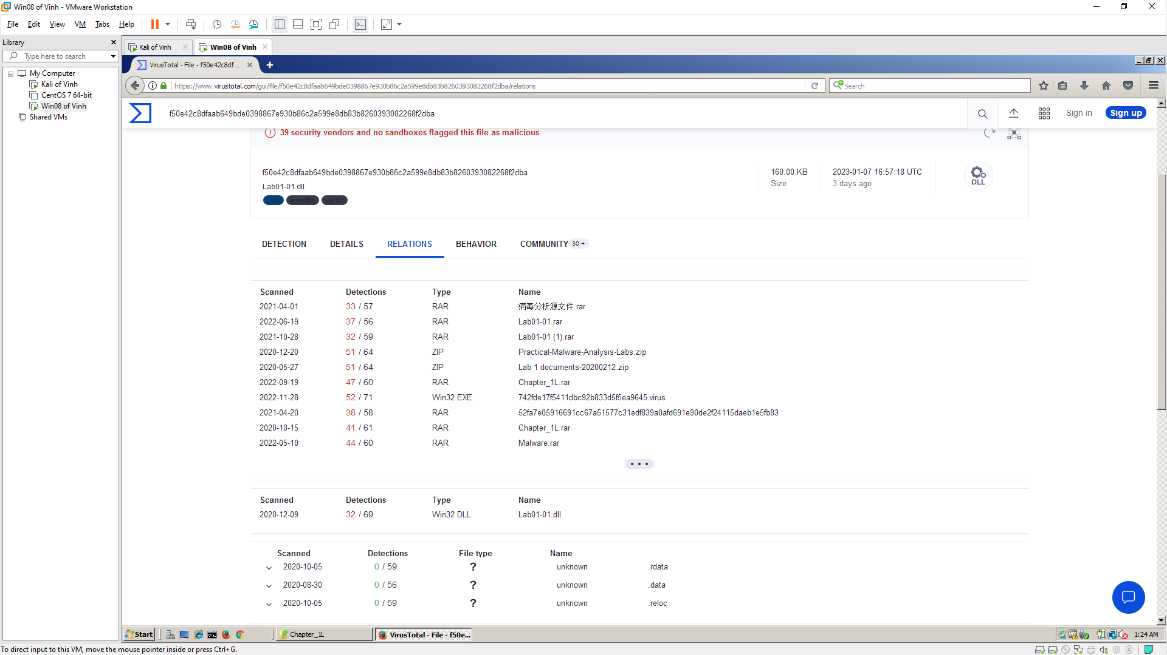

PEview
- Lab01-01.exe
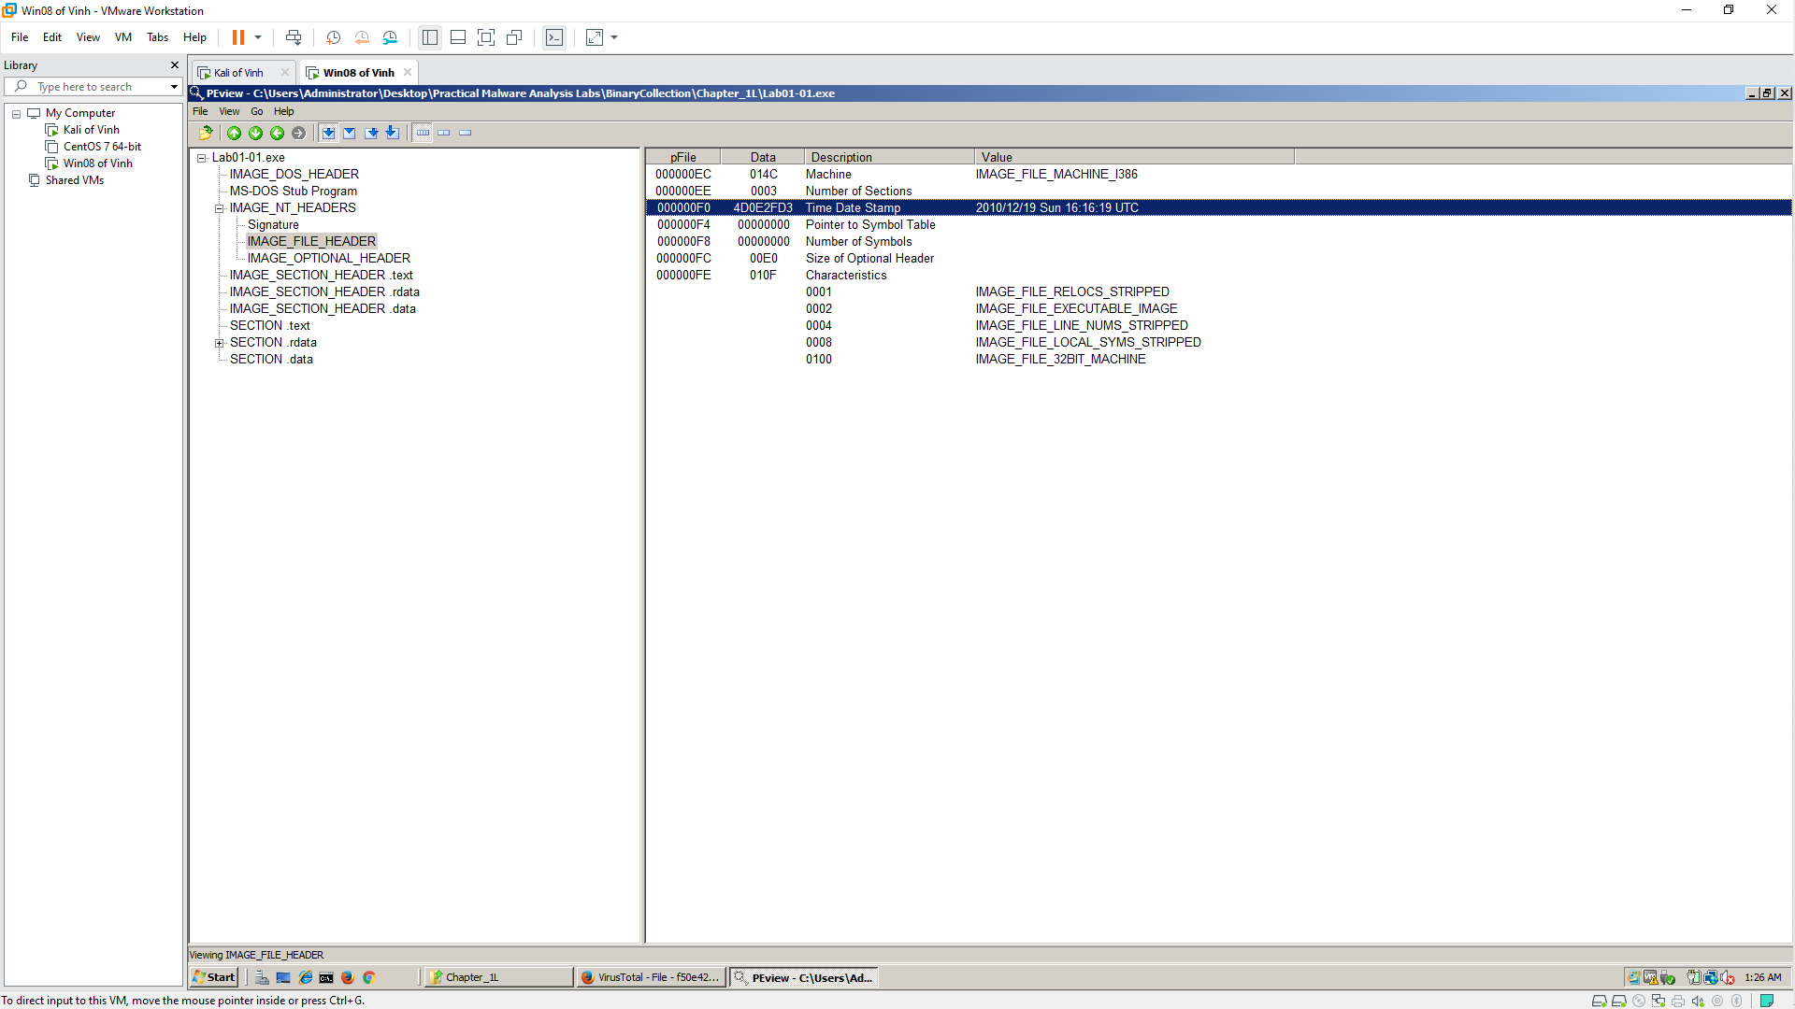

PEiD
- Lab01-01.dll
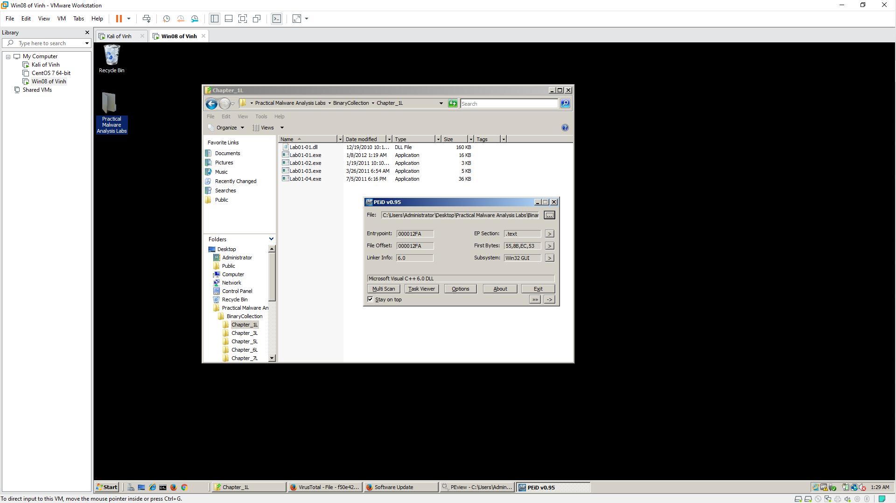

Strings
- Lab01-01.exe
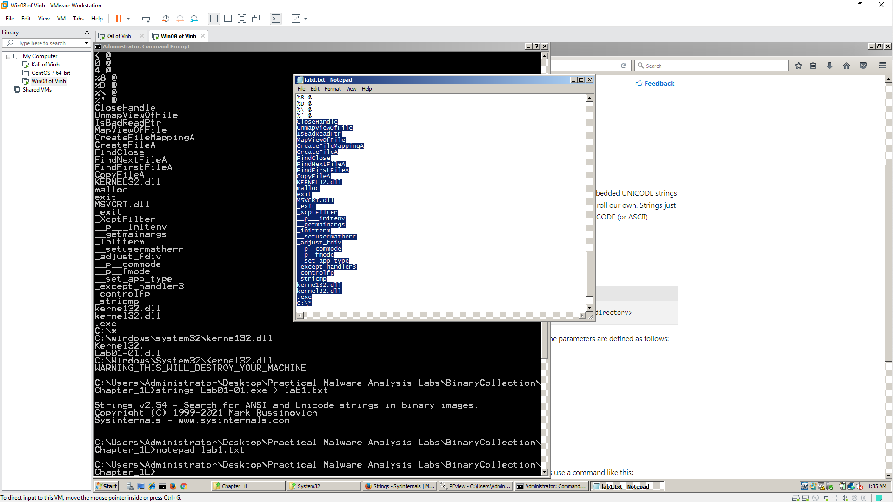
- Lab01-01.dll
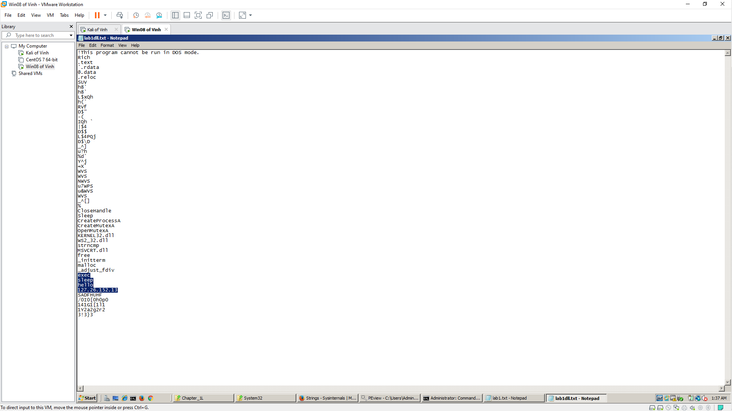

Dependency Walker
- Lab01-01.exe
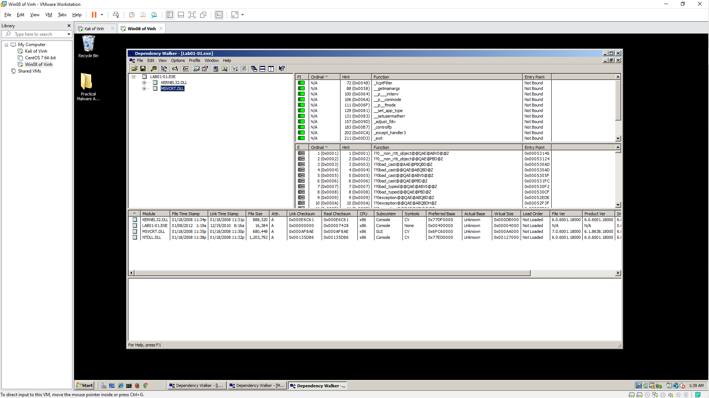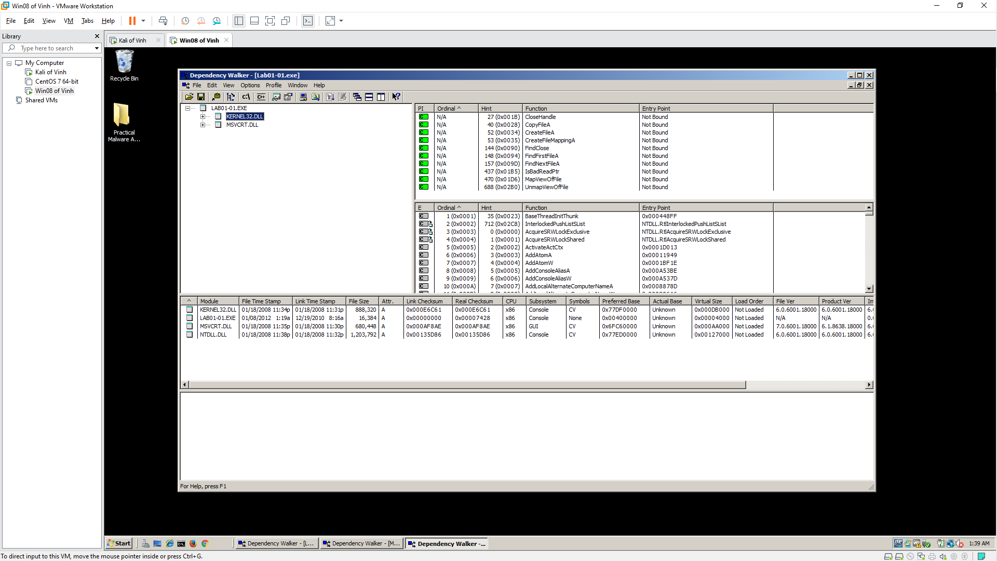
- Lab01-01.dll
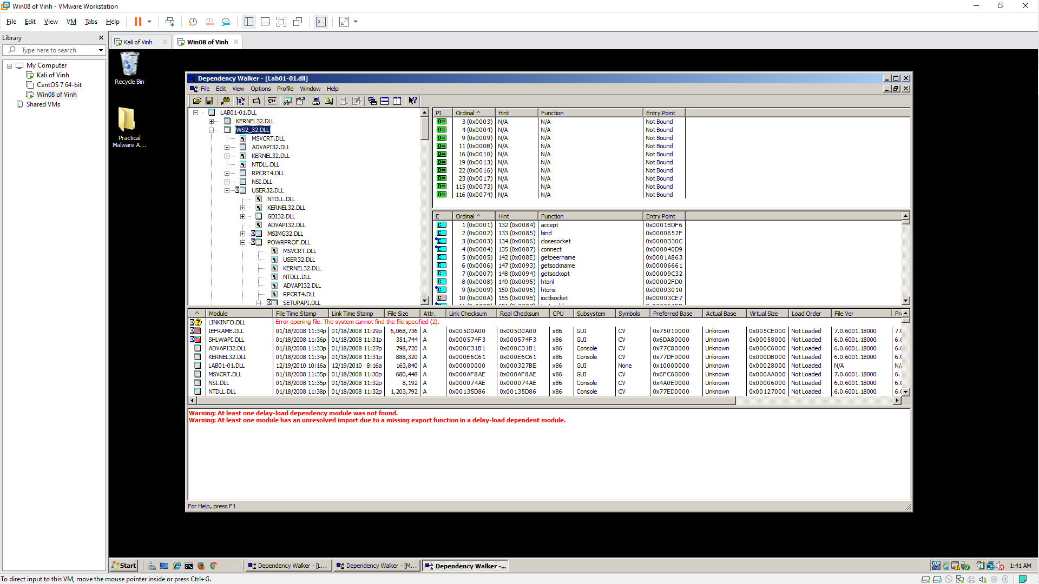

LAB 2B: Basic Static Techniques
Course Name: Malware Analysis and Reverse Engineering (IAM302)
Student Name: Nguyễn Trần Vinh – SE160258
Instructor Name: Mai Hoàng Đỉnh
Lab Due Date: 11/1/2023

Purpose
You will practice the techniques in chapter 1. This project follows Lab 1-2 in the textbook. There are more detailed solutions in the back of the book.

What you need:
- A Windows computer (real or virtual) with an Internet connection
- Recommended: the textbook: "Practical Malware Analysis"

VirusTotal
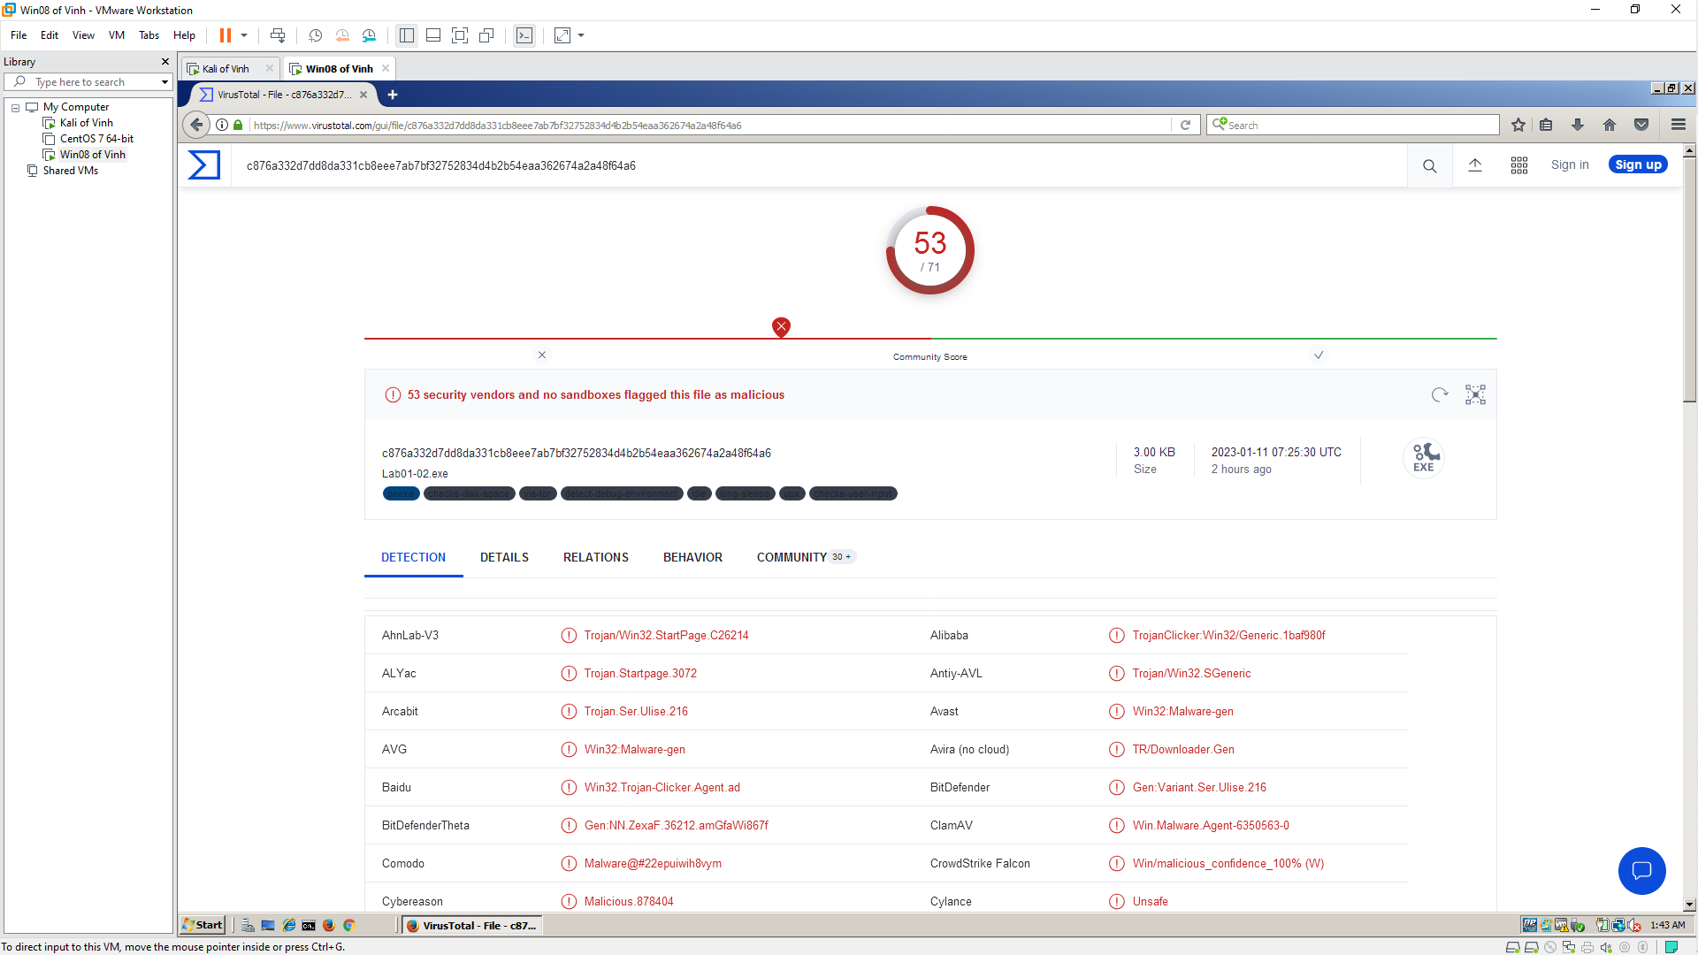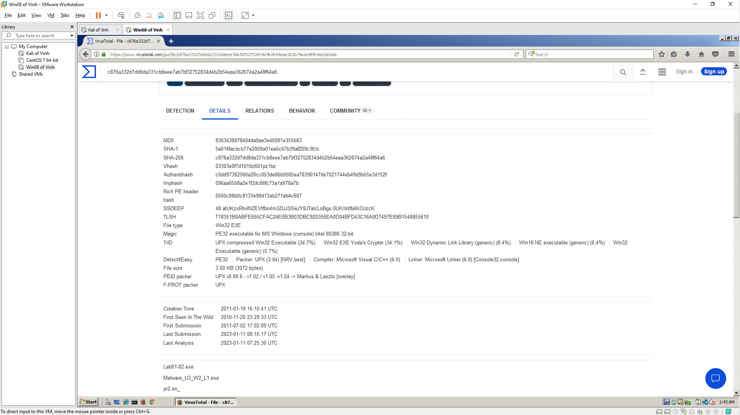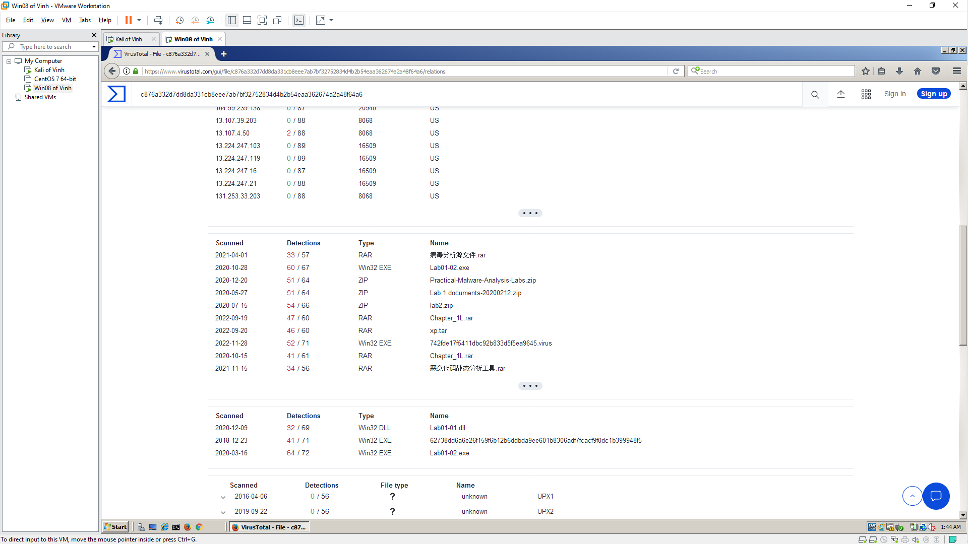

Unpacking the File
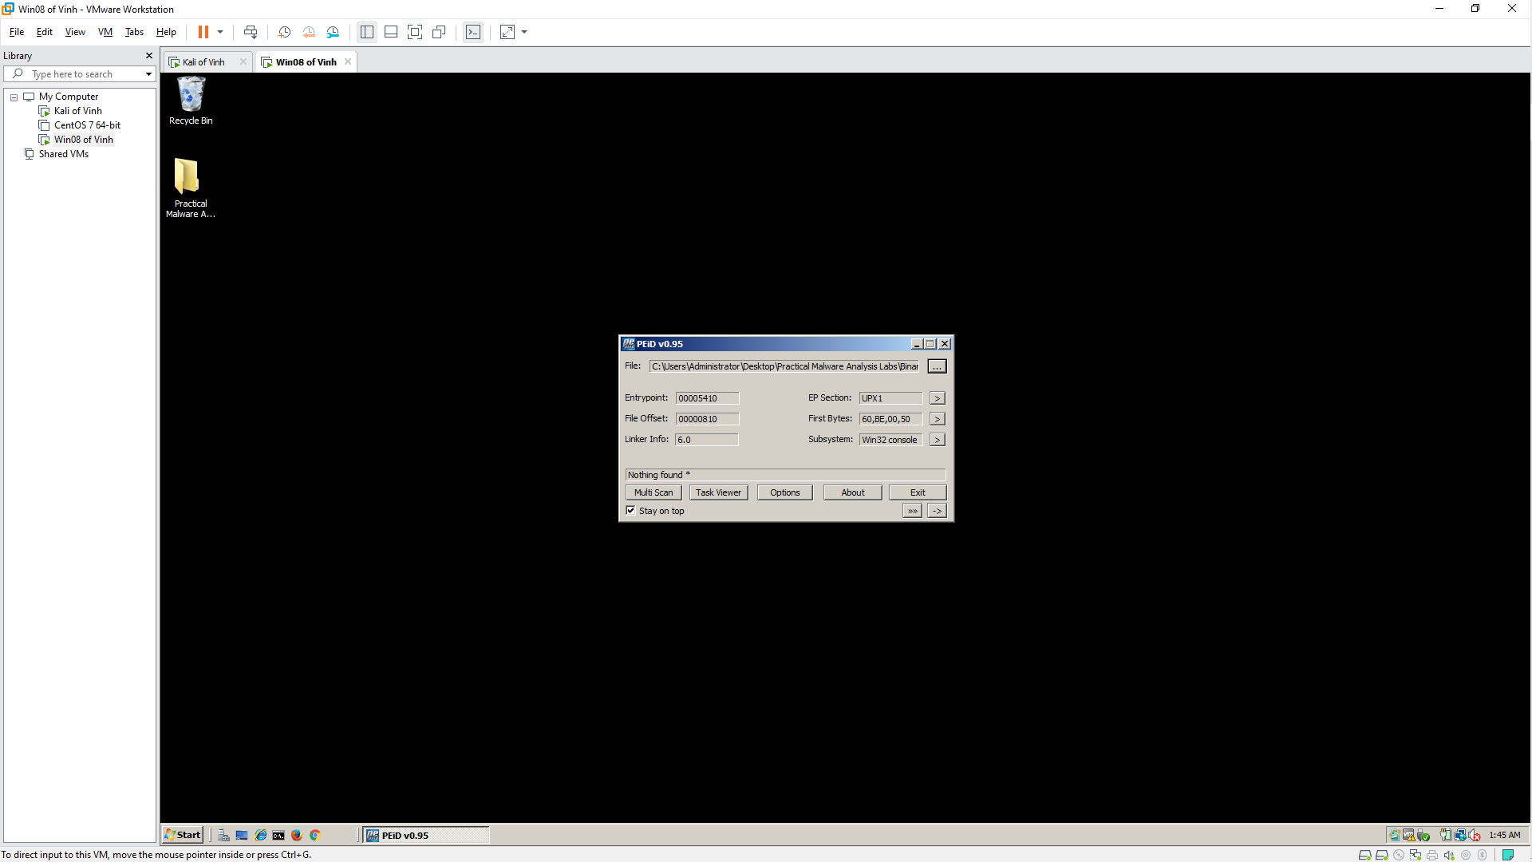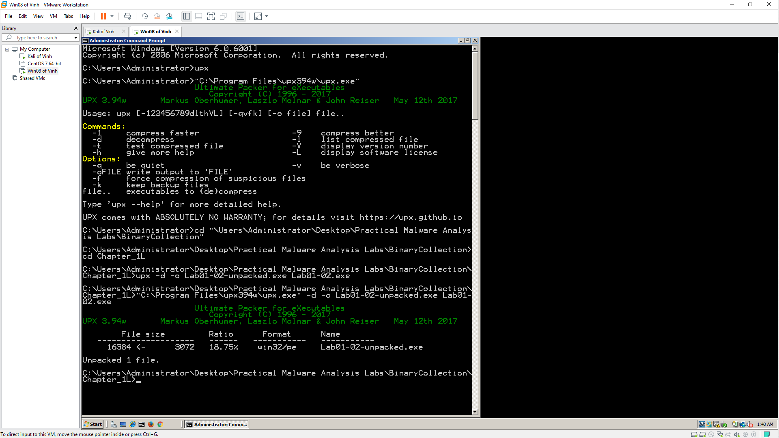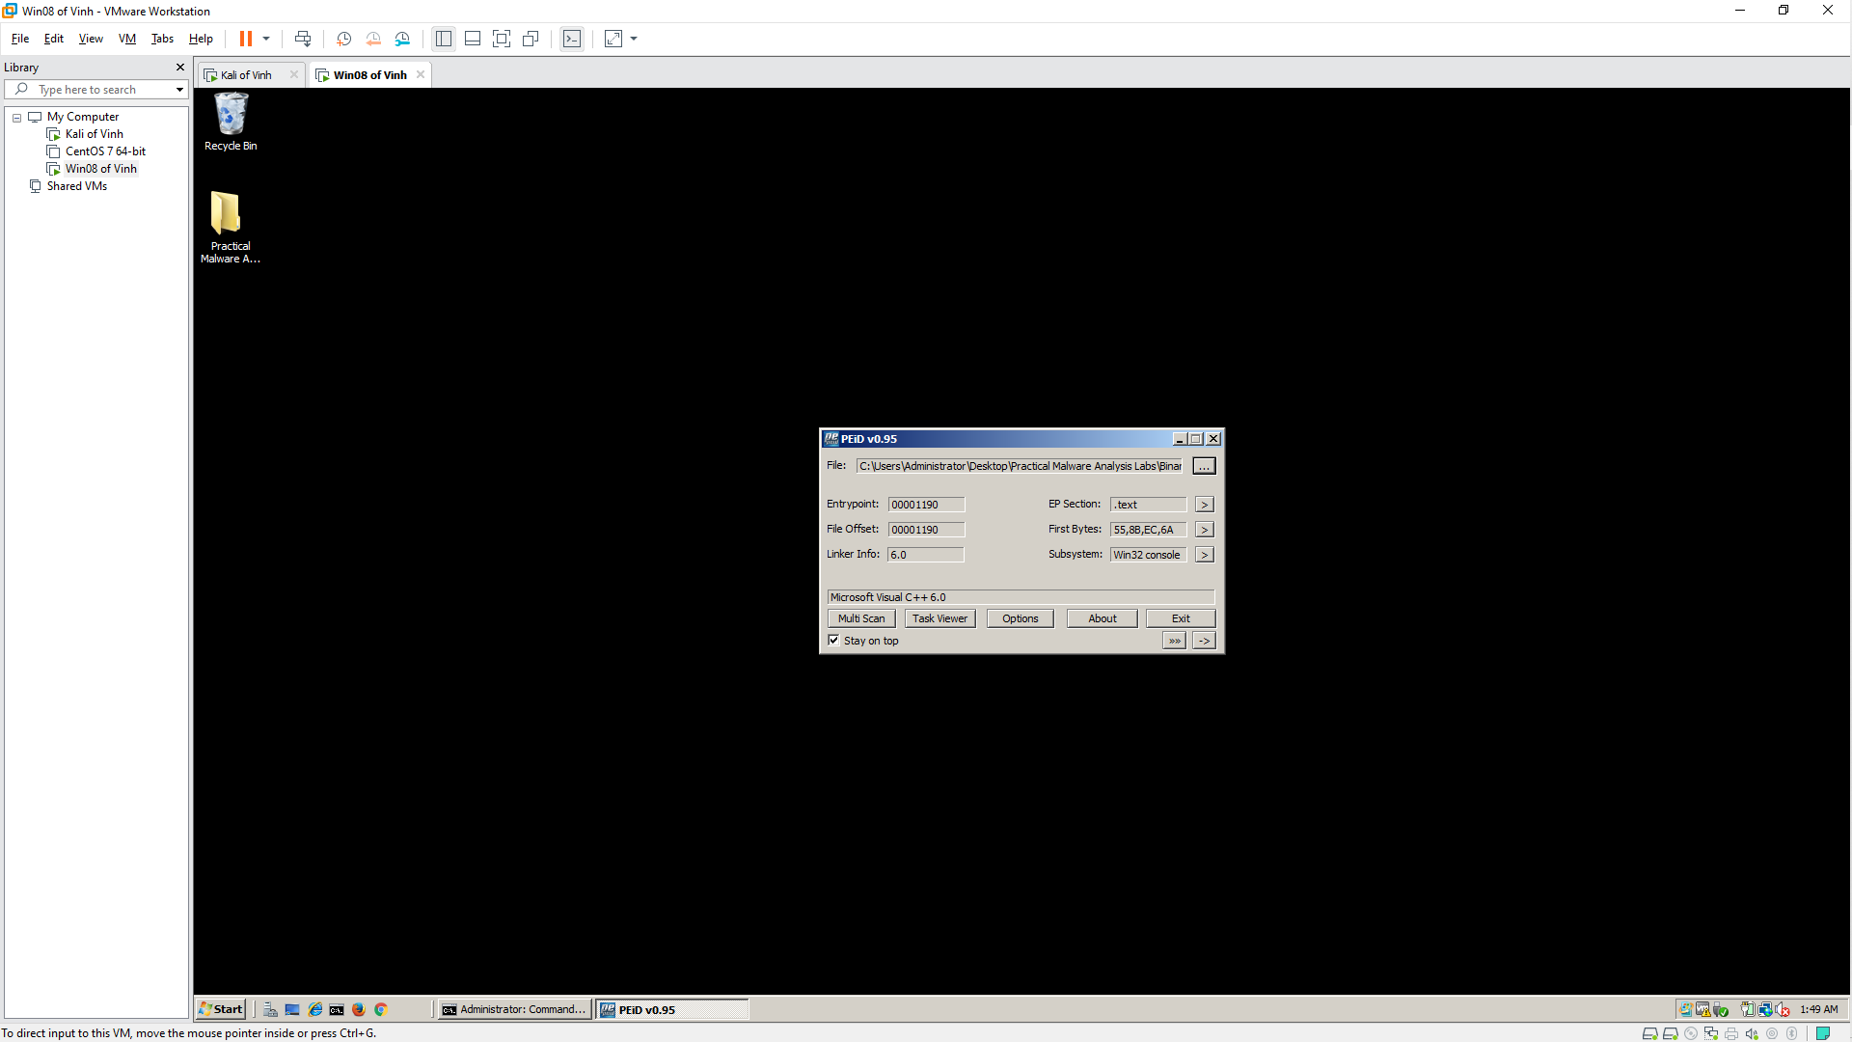

Imports
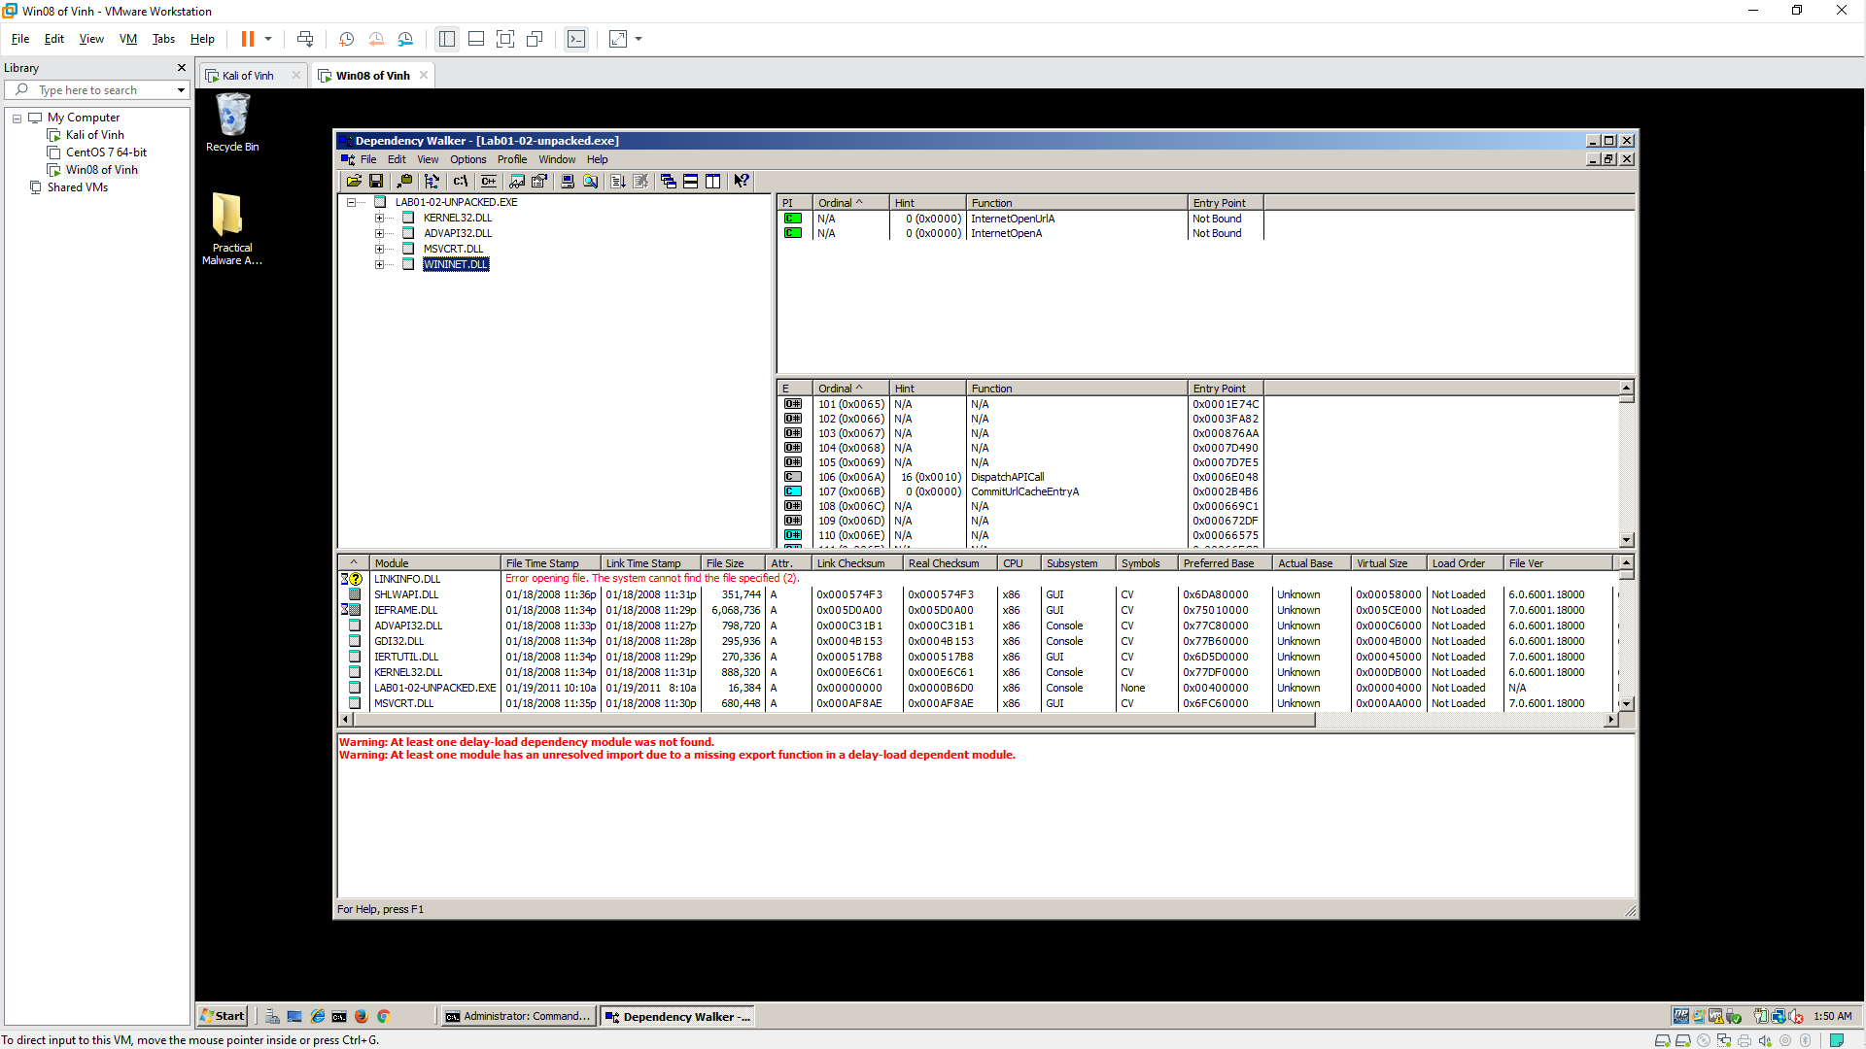

Strings
